Aug 10, 2026

Daily Standup
Invited Ketan Khamgaonkar Sakshi Gulati
Attachments Daily Standup Notes - Daily Standup

Summary
Meeting focused on administrative portal refinements and strategic payment processing shifts for platform operational efficiency.
Administrative Portal Updates
Feedback identified several display and functionality gaps within the admin dashboard. Necessary improvements include enabling direct chat features and auto-populating context for inquiry forms.
Registration and Rules Logic
System logic requires adjustments to allow multi-role user registration while preventing duplicate profiles. Sponsored events will transition to randomized selection processes.
Payment and Financial Strategy
The team decided to utilize Know Your Customer services for verification alongside Wise for payouts. This shift avoids long-term fund holding and optimizes compliance costs.

Decisions
Aligned
- Audience withdrawal logic defined The audience withdrawal functionality is disabled for participants after they have been selected.
- Brand participant selection process The participant selection option for brands in sponsored events is disabled to enforce automated selection processes.
- Payment and payout architecture strategy The payment strategy is updated to reject Stripe Connect Express due to compliance risks, in favor of a workflow using direct bank transfers, Stripe Identity for KYC, and Wise for payout distributions.
- Event listing activation condition Event listings are set to go live only after payment has been received and confirmed.

We've updated the Decisions section using your feedback.
Let us know what you think: Helpful or Not Helpful

Next steps
- [Ketan Khamgaonkar] Fix Dashboard Issues: Resolve workflow and dashboard errors identified in the shared screenshots and feedback reports.
- [Ketan Khamgaonkar] Implement Admin Chat: Enable administrators to initiate direct conversations with artists and sponsors through the admin portal.
- [Ketan Khamgaonkar] Update Profile UI: Remove the https prefix from profile links and disable the withdrawal option for participants after they are selected.
- [Ketan Khamgaonkar] Add Suggestion Box: Integrate a text box for describing and linking external events within the campaign initiation flow.
- [Ketan Khamgaonkar] Refactor Inquiry Form: Update the inquiry form to open in a new tab and auto-populate relevant reference data.
- [Ketan Khamgaonkar] Prevent Duplicate Profiles: Modify the registration process to prevent the creation of duplicate audience profiles.
- [Ketan Khamgaonkar] Review Payment Strategy: Analyze the provided research on payment systems, including the integration of Wise and Stripe for identity verification.
- [Sakshi Gulati] Finalize Terms Conditions: Review and upload the drafted terms and conditions document to the shared drive.
- [The group] Meeting: Conduct a meeting on Wednesday to review resolved issues.
- [Ketan Khamgaonkar] Share Documents: Provide documentation to Sakshi Gulati to assist in resolving the ongoing issues.

Details
Did the screenshots in this section make your notes better or worse?
- Meeting Opening and Health Check: Ketan Khamgaonkar and Sakshi Gulati exchanged greetings and discussed Ketan Khamgaonkar's recent recovery from a fever.
- Dashboard Feedback Workflow: Sakshi Gulati reviewed dashboard feedback from the previous week, noting a specific workflow issue where information was not displaying correctly. Ketan Khamgaonkar identified that the problem stemmed from a missing workflow setup and committed to resolving it after the meeting.
- Admin View - Editing Event Details: Sakshi Gulati reported an issue in the admin view where key details, such as ticket price and capacity, were not visible or editable when managing events.
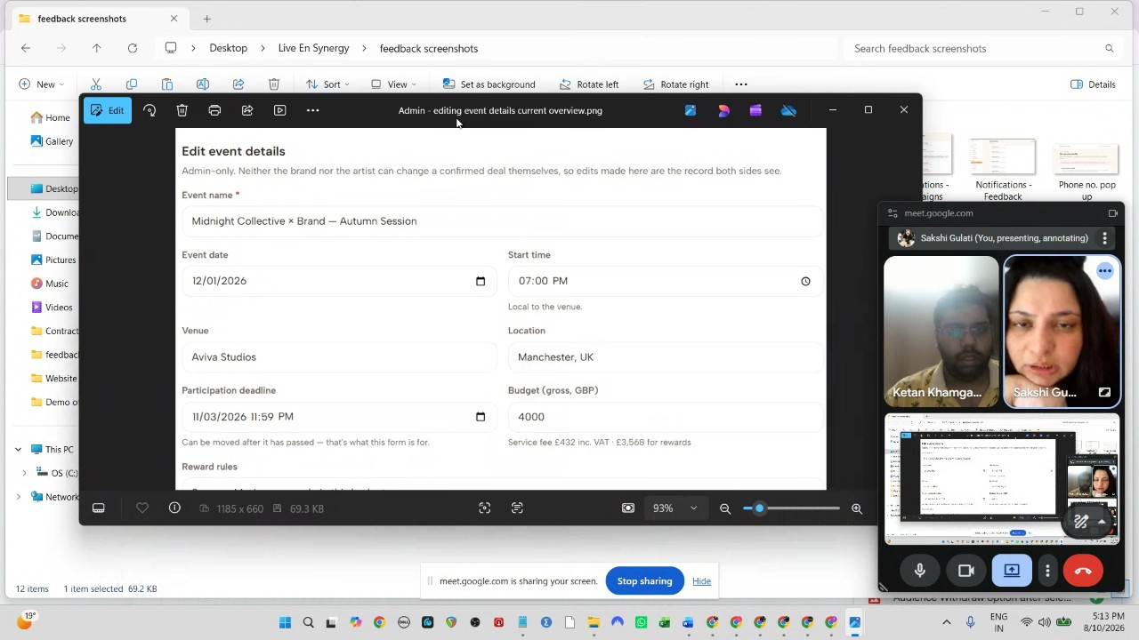
- Admin View - Chat Readability: Sakshi Gulati noted that it is difficult to distinguish between speakers when reviewing conversation logs between artists and sponsors in the admin portal.
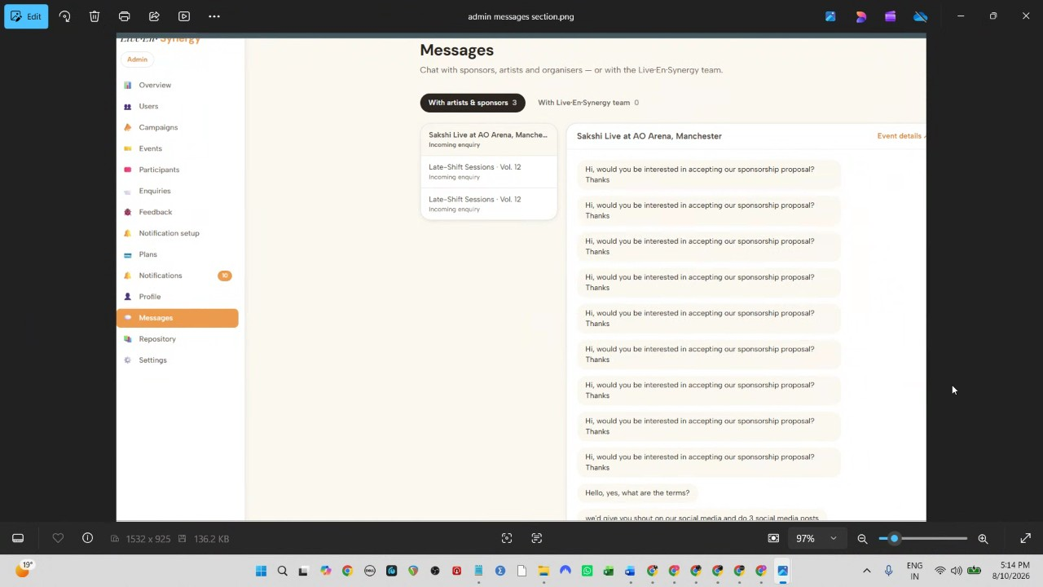
- Admin View - Direct Communication: Sakshi Gulati proposed adding functionality to the admin portal that allows for initiating new chats directly with artists and sponsors.
- Artist Profile - Link Formatting: Sakshi Gulati requested an update to remove the "HTTPS" text from the artist profile section to improve the user interface.
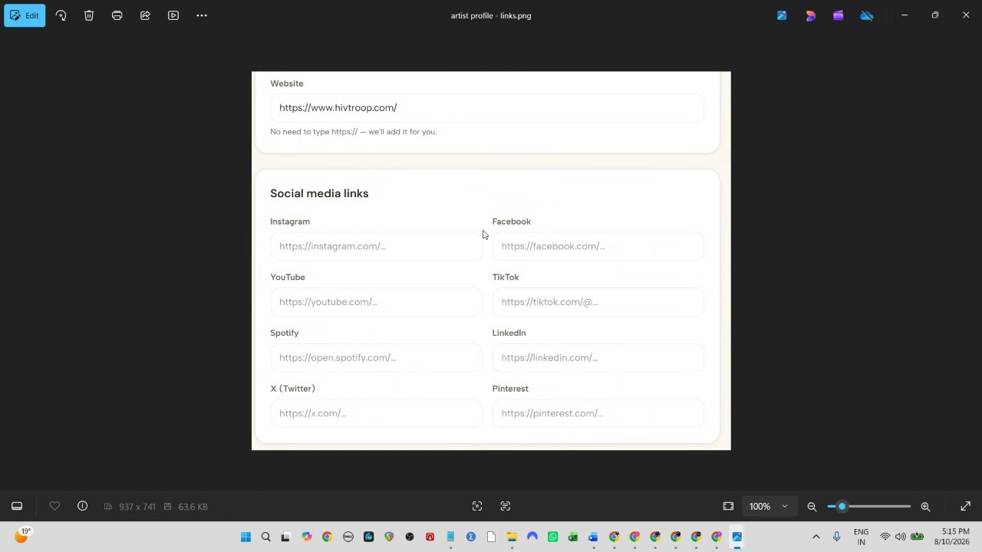
- Audience Participation - Withdraw Option: Sakshi Gulati identified that audience members currently have the option to withdraw after being selected for an event, which needs to be disabled.
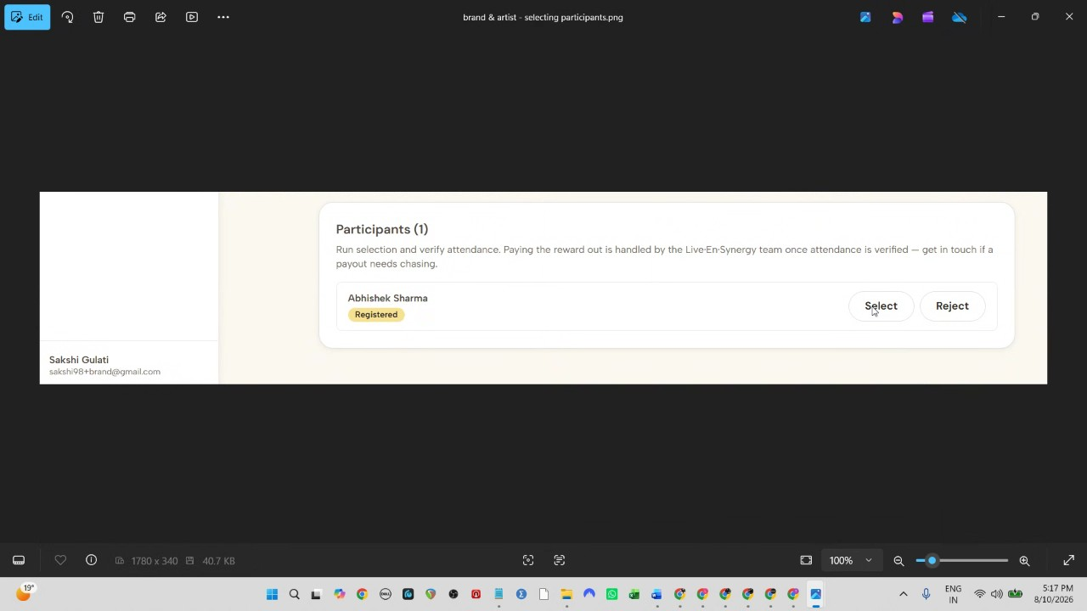
- Sponsored Event - Selection Logic: Sakshi Gulati and Ketan Khamgaonkar discussed restricting the selection option in sponsored events, as this should be handled by a randomizer rather than manual selection by brands or artists.
- Campaign Overview - External Link Suggestion: Sakshi Gulati proposed adding a text box to the campaign overview section, allowing brands to suggest external events or links to artists, which would then be shared via the chat.
- Inquiry Form Context Loss: Sakshi Gulati noted that navigating to an inquiry form causes a loss of context regarding the specific sponsorship number. Ketan Khamgaonkar suggested that the form should open in a new tab with relevant reference data auto-populated.
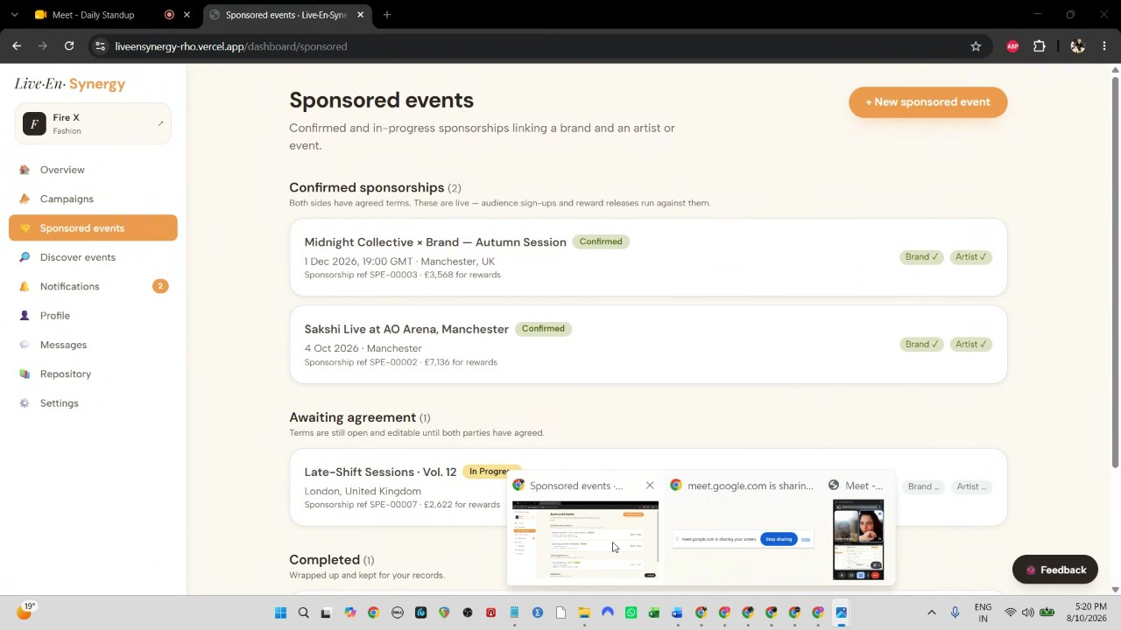
- Inquiry Dashboard Visibility: Sakshi Gulati reported that inquiries appearing in the dashboard lack event reference details, making them difficult to track, and requested the ability to message inquirers directly from the dashboard.
- Notification Reference Details: Sakshi Gulati noted that notifications regarding campaigns and feedback are missing necessary reference details, such as specific campaign or submission numbers.
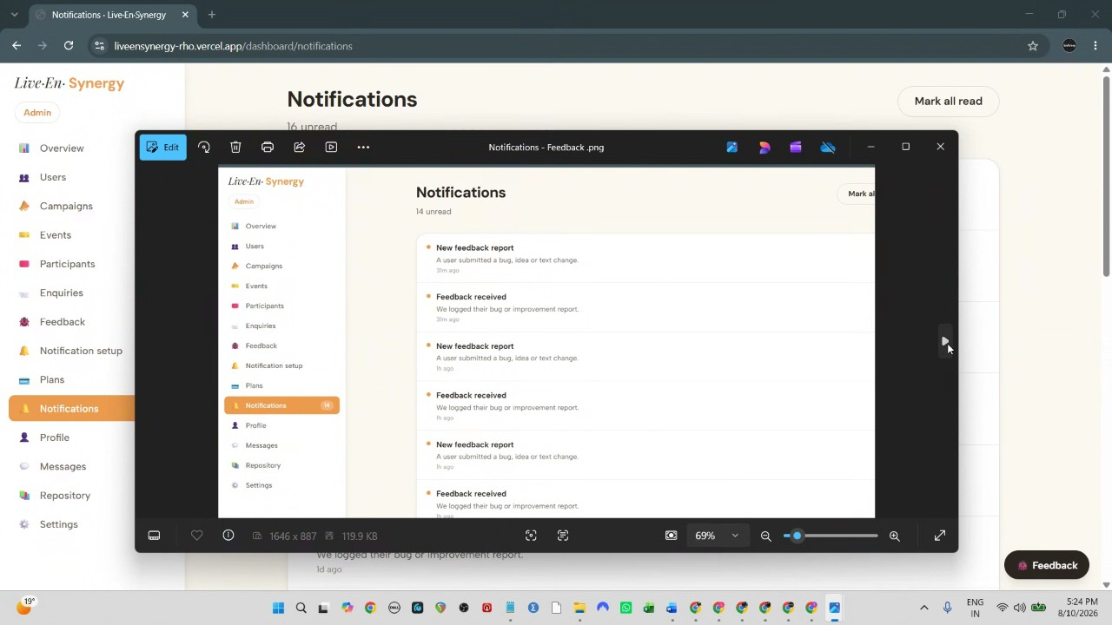
- Profile Duplication: Sakshi Gulati highlighted an issue where users could not register as different roles (e.g., artist and audience) using the same phone number. They agreed that while duplicate audience profiles must be prevented, the system should allow the same individual to register for multiple roles.
- Payment Processing Strategy - Stripe Limitations: Sakshi Gulati explained why Stripe is not suitable for their platform, citing the risk of account freezing due to high-ticket sponsorship anomalies, the lack of escrow services, and compliance issues regarding holding funds for extended periods.
- Alternative Payment Solution: Sakshi Gulati proposed using Stripe Identity for KYC and anti-money laundering verification, costing 125 per person, and using Wise for automated payouts, which is more cost-effective and avoids long-term fund holding.
- Financial Structure and VAT: Sakshi Gulati outlined a proposed financial model including a 9% platform commission plus 2.5 per payout. They clarified that while platform fees attract VAT, the sponsorship pool money does not, and any remaining balance from sponsorship funds can be refunded or used for future events.
- Terms and Conditions Documentation: Sakshi Gulati confirmed that the terms and conditions document is nearly complete and will be uploaded for review.
- Webhooks and Real-Time Status: Sakshi Gulati and Ketan Khamgaonkar discussed using webhooks to trigger real-time updates, such as automatically setting an event to "live" status once sponsorship payments are confirmed.
- Bank Account Onboarding: Ketan Khamgaonkar confirmed that user bank account details will be collected and verified through the API to prevent errors.
- Future Meetings: Sakshi Gulati and Ketan Khamgaonkar agreed to meet again on Wednesday or Friday to continue reviewing these updates.

You should review Gemini's notes to make sure they're accurate. Get tips and learn how Gemini takes notes
How is the quality of these specific notes? Take a short survey to let us know your feedback, including how helpful the notes were for your needs.

